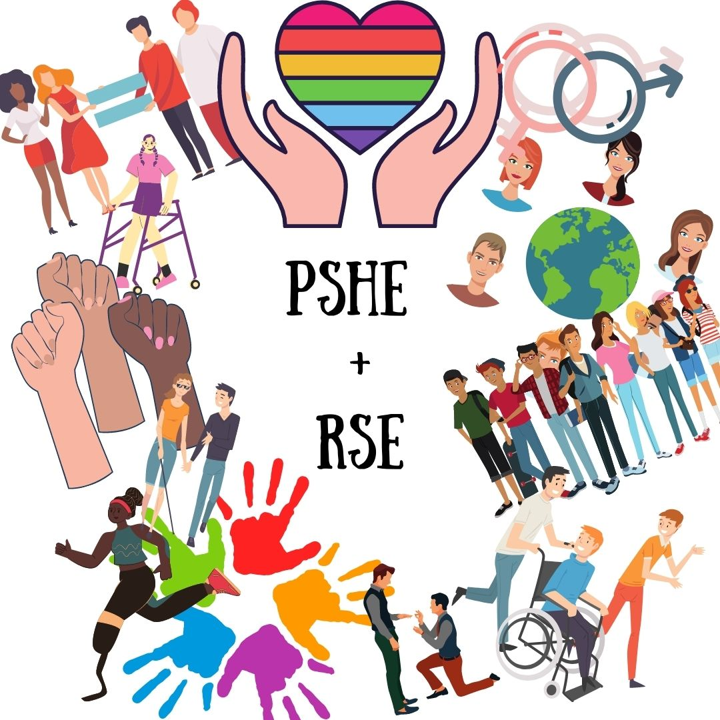
What does PSHE look like at our school?
Our PSHE (Personal Social Health Education) curriculum has been designed around the requirements of the National Curriculum; the programmes of study being the basis for learning and adapted to meet the needs of our pupils. We also regularly refine the curriculum in line with the latest guidance, subject research reports from Ofsted and current affairs.
We use two schemes of work to support the teaching of PSHE:
- Jigsaw for the PSHE part of the curriculum
- Ten:Ten Live ‘Life to the Full’ for the RHE (Relationships and Health Education)
We have adapted both of these schemes to be taught alongside each other throughout the year, ensuring that all requirements of the National Curriculum are met. PSHE is taught for one hour a week but elements of PSHE are incorporated throughout our curriculum.
A primary focus is to raise aspirations, engender a sense of personal pride in their achievements and provide a purpose and relevance for learning. This is taught throughout the scheme of Jigsaw and across the whole curriculum. We aim to deliver an inclusive curriculum and aim for a non-tokenistic approach to teaching it, which celebrates various cultures and diversities so that our children are equipped to become active and responsible citizens.
We endeavour to fulfil the potential of every child academically, socially, morally, spiritually and culturally so that they are ready for the next stage in their lives. One area which will be of particular importance this year is Relationships, Sex and Health Education. Following on from the pandemic, we will continue to help them look after their own mental health and well-being, their physical health and fitness as well as helping them to build safe and respectful relationships with others. Parents will understand why we continue to teach children how to stay safe online in our computing and PSHE lessons.
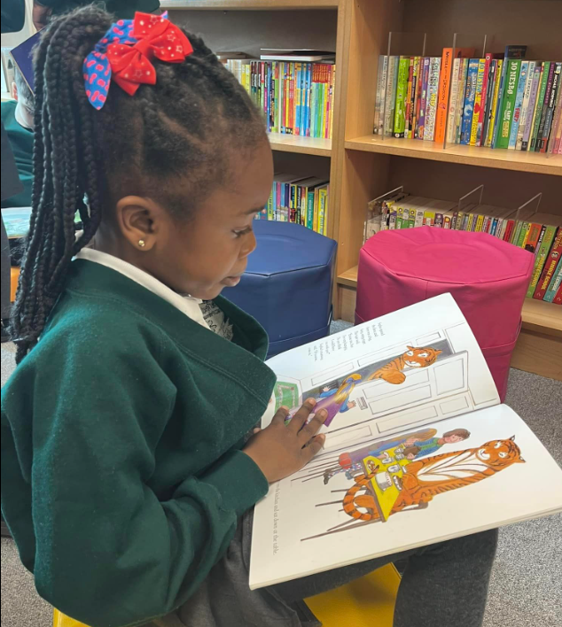
Reading
Teaching children to read is always our biggest priority and so this takes up a significant amount of time on the timetable. Since the pandemic, we have invested in PSHE rich texts to ensure that our children are exposed to topics including resilience, families, adoption, health, the economy, safety, citizenship, human rights, democracy and more. Our school library is open for business to promote and foster a love of reading for pleasure and to contribute to the social development of the children in school. Books have been carefully selected to ensure that the protected characteristics are represented positively, our children are represented in stories as well as celebrating diversity and building better cultural awareness.
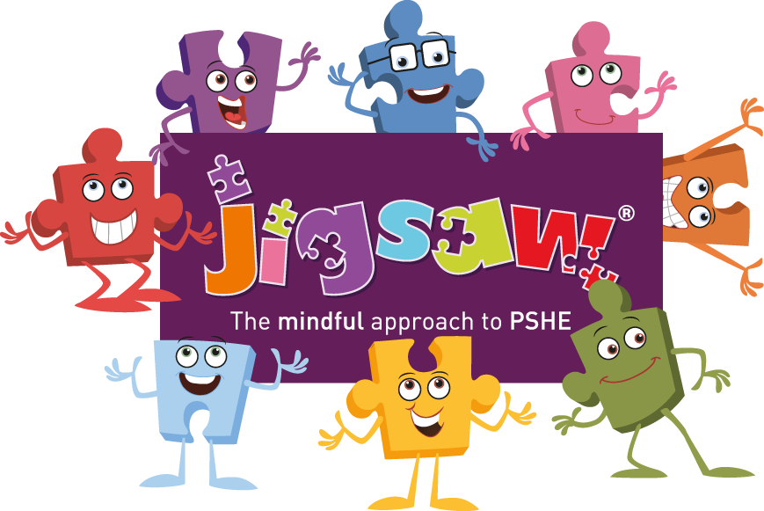
Jigsaw
The Jigsaw scheme of work is a universal whole-school curriculum that builds social skills, grows emotional literacy, enables mental health and nurtures children’s positive relationships with themselves and others. Through the teaching of PSHE, we aim to open the pupil’s eyes to the choices and possibilities waiting for them in the world of work. We engage them in current affairs and teach them about the key social and political issues in their futures. Our children have thrived in becoming ambassadors for change when debating about the BLM movement, holding their own G7 summit and creating their own climate emergency marches.
Teaching strategies are varied and are mindful of preferred learning styles and the need for differentiation.
Jigsaw is designed as a whole school approach, with all year groups working on the same theme (Puzzle) at the same time.
We have adapted the Jigsaw scheme of work to run alongside our RSE Ten:Ten scheme and therefore only use four of the Puzzles in Jigsaw:
- Being Me in My World
- Celebrating Difference (including anti-bullying)
- Dreams and Goals
- Healthy Me

Every Jigsaw lesson is structured in the same way so that a consistent approach is used throughout school.
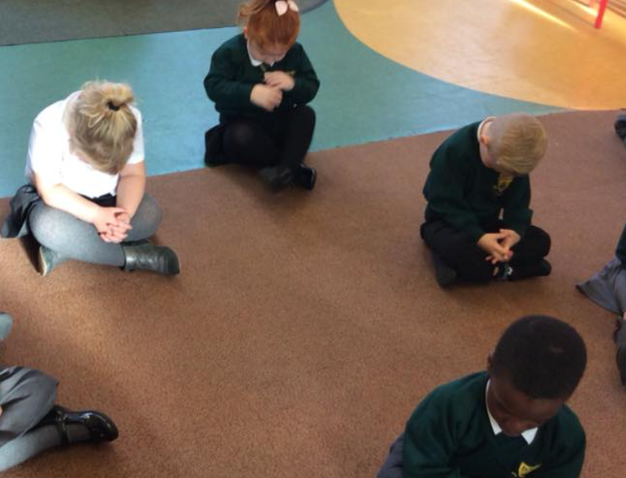
Each lesson involves:

- Improve their social skills to better enable collaborative learning (Connect us)
- Relax their bodies and calm their minds to prepare them for learning (Calm me)
- Help the brain to focus on specific learning intentions (Open my mind)
- Initiate new learning (Tell me or show me)
- Facilitate learning activities to reinforce the new learning (Let me learn)
- Support them in reflecting on their learning and personal development (Help me reflect)

Through the scheme, our pupils are taught to be aware of their thoughts and feelings as they arise and have been taught and practised how to use interventions e.g. breathing (Calm Me) techniques, they can choose to regulate/ manage their thoughts and feelings by using these interventions.
Mindfulness is taught through the ‘Calm Me’ time in each lesson; this consists of breathing techniques, awareness exercises and visualisations, enabling children not to empty their minds but to quiet them and become aware of the activity within them and manage it positively. It is also taught through the curriculum. Lessons help children to explore their thoughts and feelings, to expand their emotional vocabulary, explore thoughts-feelings-consequence sequences, build their confidence and express themselves in a safe environment.

Ten: Ten

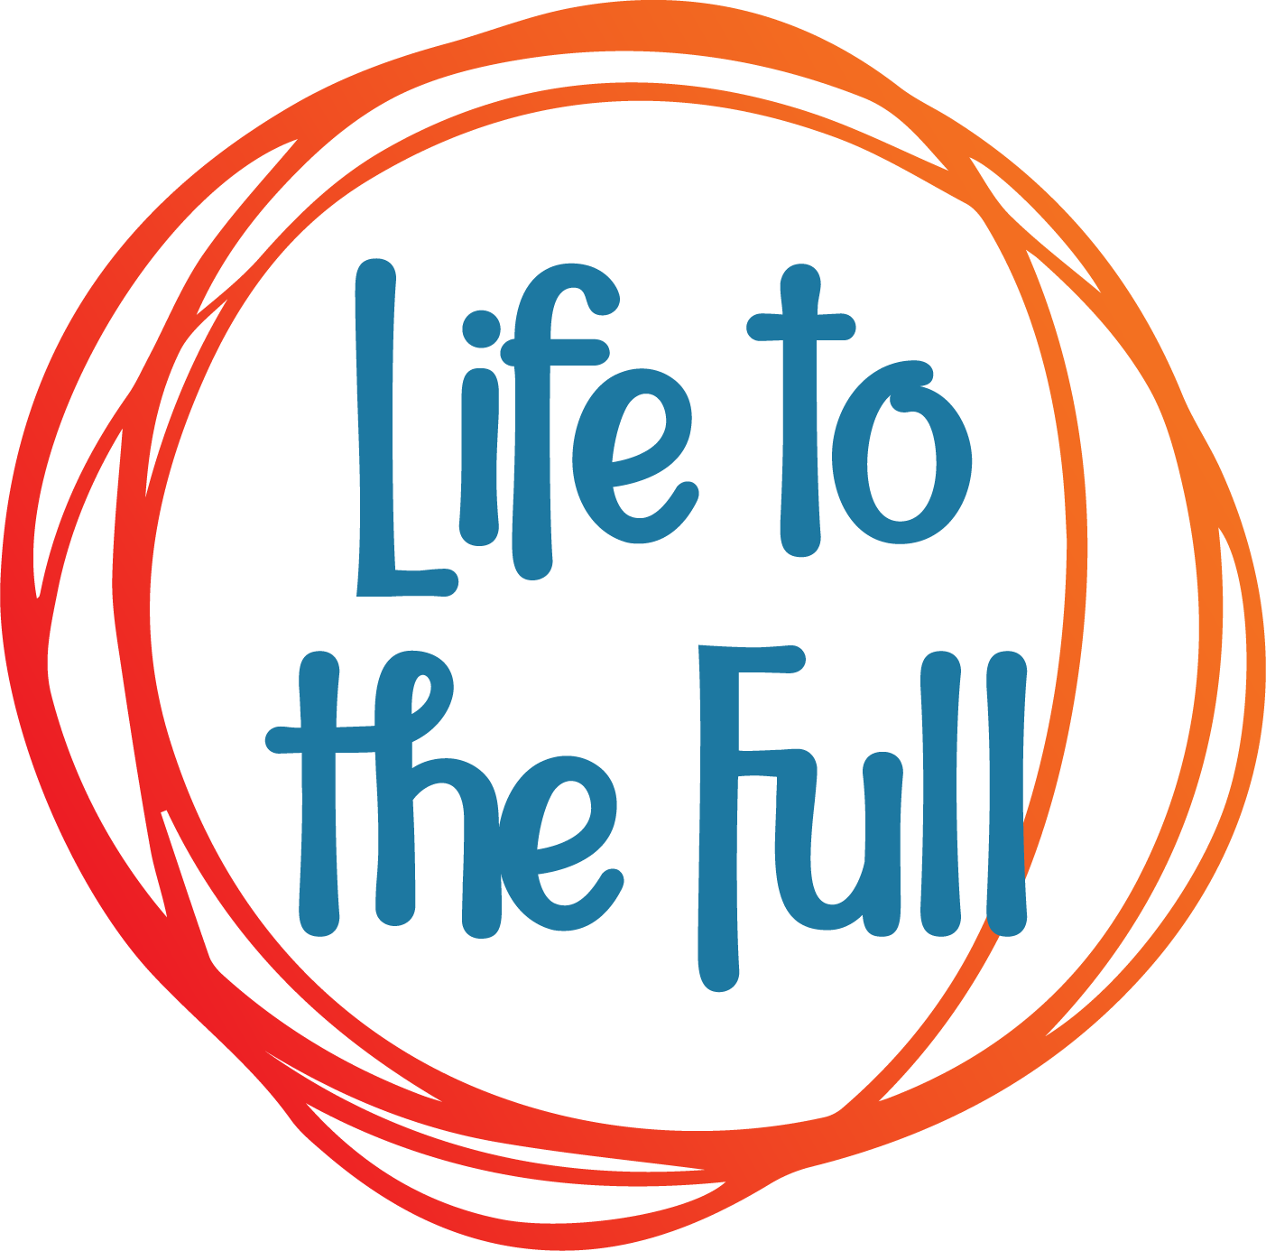
Ten: Ten is the scheme of work we use for the teaching of the RHE elements of the curriculum. Taught with a spiral approach to learning in which pupils will revisit the same topics at an age-appropriate stage through their school life, the programme includes teaching about personal health, physical and emotional well-being, strong emotions, private parts of the body, personal relationships, family structures, trusted adults, growing bodies, puberty, periods, life cycles, the dangers of social media, where babies come from, an understanding of the Common Good and living in the wider world. The entire teaching is underpinned with a Christian faith understanding that our deepest identity is as a child of God – created, chosen and loved by God. The programme is fully inclusive of all pupils and their families.

Extra support
Sometimes during their time at school, some children need extra support in certain subjects. Personal, Social and Health Education may be an area that your child struggles with. We appreciate that PSHE is an area where some pupils may have a higher need for support dependent on their own experiences and ability to express their emotions and feelings.
The teaching of PSHE for our all of our pupils is inclusive. We ensure that all children are able to access the same learning objectives. We ensure that all pupils are supported where needed prior to, within and after the lesson. We allow for the children to record their lessons in different ways where needed – for example by recording their responses in picture form, or verbal rather than written. ICT is used where needed for recording and communicating thoughts in different ways. Where needed, differentiated learning materials are provided ensuring that children are accessing the National Curriculum but through scaffolded tasks and questioning. Support staff are used where needed to support individuals throughout their PSHE lessons. Where needed we access additional support for pupils with emotional and social needs with the help of educational psychologists. We identify pupils who need support for their emotional needs who may not necessarily need support elsewhere in the curriculum. These pupils receive more time with support staff through activities such as Lego therapy. We ensure in curriculum time, these pupils are prepared of lesson objectives and activities planned. This is also the same for children who would struggle with specific sensitive topics being covered.

Safeguarding and well-being
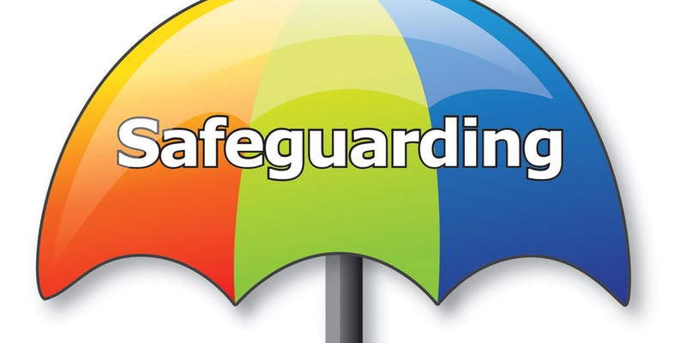
A child’s welfare, well-being and safety is of the utmost importance to us. A child can’t learn or make any progress in school if they don’t feel safe or secure. We all know they need to be happy and we are here to ensure all of our children are nurtured to reach their full potential.
There are elements of the Jigsaw scheme of work that have a strong safeguarding focus in particular, obvious to teachers but not necessarily so explicit to children. Teachers are very aware that discussions in PSHE lessons could well trigger a recall of a disturbing event or memory for any children and are trained in how to deal with this. Our philosophy is to grow resilience and positive self-esteem and confidence in children, so they can recognise when they feel uncomfortable in a situation and know who to trust and how to speak up for help. They respect themselves and their bodies and know what healthy relationships feel like. Our Designated Safeguarding Leads are available for parents to discuss any concerns you may have about your child.

Assessment
Assessments in PSHE are carried out in various forms.
- Pupil voice – questionnaires
- Ambassadors for Change sessions
- SMSC challenges
- Class teacher assessments against the age-related expectations (AREs)

The personal nature of PSHE means that it cannot be assessed in the same way as other subjects. It is possible to recognise and evidence progress and attainment in the knowledge, understanding, skills and attributes PSHE strives to develop in the individual. These assessments and outcomes are an invaluable tool for the subject leader to measure the impact of these target days/weeks within the current system of PSHE delivery.

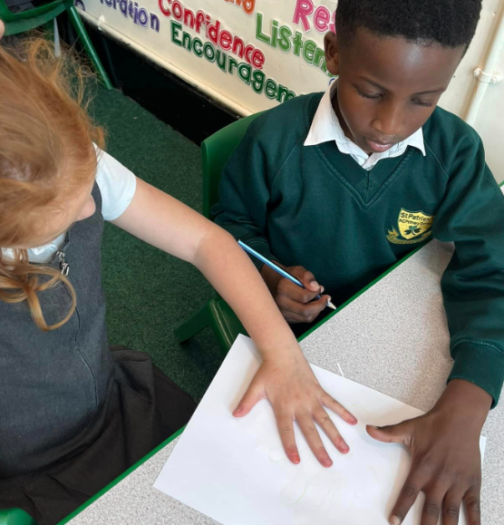
Personal Development
The Jigsaw scheme of work we are using is more than a PSHE Scheme of Work. It provides a structured programme of personal development to nurture the ‘whole child’ and increase learning capacity, underpinned by mindfulness philosophy and practice. Every Jigsaw lesson from Early Years to KS2 offers opportunities for children’s spiritual, moral, social and cultural (SMSC) development, and this is clearly mapped and balanced across each year group. SMSC is not taught in isolation through PSHE. We aim to ensure SMSC links are made across the curriculum and SMSC challenges are included in lessons.

How do we adapt our PSHE curriculum?
Our PSHE curriculum is particularly responsive to the world around the children, whether that be on a localised scale or on a worldwide scale. Children want to share, to discuss and offer their opinions in a sensitive and age appropriate way. Teachers are mindful of areas of the curriculum children need to focus on and adapt their planning accordingly. This is particularly important because some key knowledge, skills, vocabulary and concepts will always need working on. Prior knowledge will be assessed before starting a new unit of Ten:Ten or Jigsaw and areas will be revisited where needed.

How can I support my child’s learning in PSHE?
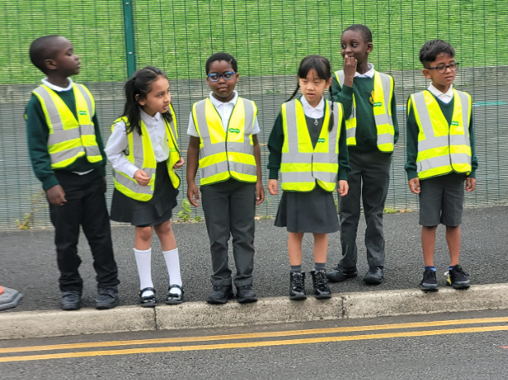
There is so much you can do! Firstly, listen to your child and encourage them to talk about what they have been learning in lessons. Access our Facebook, Instagram and class dojo stories as this will help you to start conversations. More than likely, you will be a ‘trusted person’ for your child and more often than not, they will talk to you about any worries or concerns. Encourage calming and mindfulness time in your home – your child loves to do it and they’re really good at it from an early age! Share the ‘reading for pleasure’ books your child brings home. These should ignite interesting conversations and will tackle modern day issues for you to discuss. Enjoy this special time with your child.

