What does Modern Foreign Languages look like at our school?

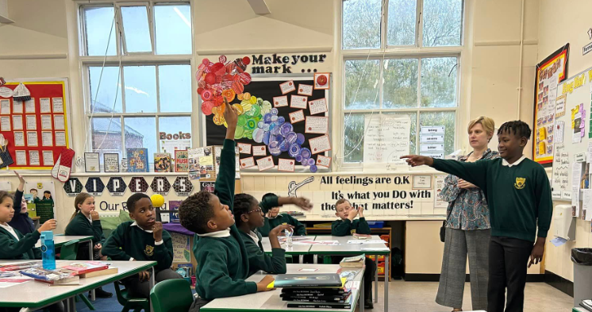
Languages are an essential part of a broad and balanced curriculum and all our children in Key Stage 2 (Years 3 -6) have the opportunity to learn a different language. Not only do they provide an opportunity to communicate more effectively with others, they also help children to understand what it is to be a global citizen and, in some cases, celebrate their home language. It also includes the importance of tolerance and understanding, which are crucial skills in today’s modern world.

At our school, the children learn German and they receive weekly lessons lasting 30 minutes. Once a fortnight, the children are taught by a specialist language teacher who supports the classroom teacher with the correct pronunciation and grammar. On the weeks where the specialist teacher is not in class, the classroom teacher delivers the lesson.
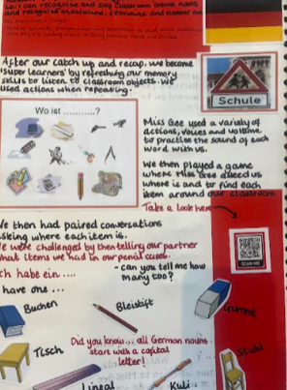
Our curriculum meets the requirements of the National Curriculum but is regularly refined in line with the latest guidance, subject research reports from Ofsted and current affairs. We follow a scheme of work to deliver our Language lessons, which provides the teachers with lots of resources to help deliver the lessons in an exciting and engaging way. The children learn to speak German through games, songs and stories, making the lessons practical and fun. You would expect to see lots of talking, actions and singing in our Language lessons!
Lessons are recorded and evidenced using a ‘Big Book’, which the children can look at and refer back to, in order to track their own progress and revisit prior learning.

Reading
What has learning German got to do with reading? Lots of our children LOVE learning German because much of the lesson doesn’t involve too much reading! But, if we really want to foster a love of modern languages, an understanding of other cultures, a desire to travel, your child is going to need to read! Reading unlocks all sorts of opportunities! We have a saying in our school, ‘we learn to read so we can read to learn.’ So, please support your child with all of their learning by hearing them read each night.

Assessment
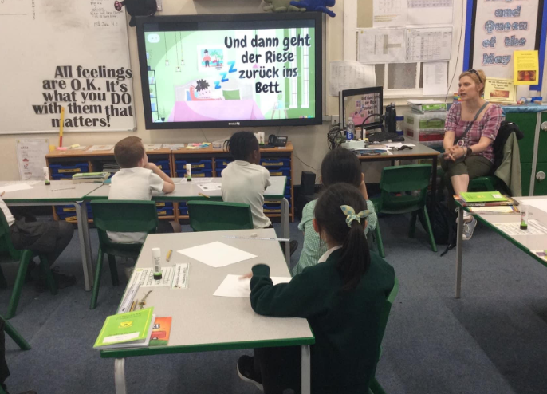
Assessment has to serve a purpose and teachers are continually assessing the children in all types of ways so they can help them progress with their language learning. In every lesson, teachers are questioning and discussing with pupils to find out what they do or do not know so that we can give extra support. We have very focused tests at the end of each unit so we can find out who has remembered what. As well as the tests, teachers assess children continually after each lesson using a tracker. This really helps the teachers find out what gaps might need to be filled in the following years.

Extra support

Sometimes during their time at school, some children need extra support in certain subjects. This is because children learn at different paces and in fits and bursts. It isn’t anything to worry about and it is good that we can provide them with extra help when needed. The good thing about learning a new language is that all children started at the same point and this gave lots of our children a real boost. At our school, we use our teaching assistants in class to provide extra support to the children who need it. However, in our Languages lessons, the children are all really supportive of each other and help each other with the correct pronunciation. Parents, if you are concerned about your child’s learning and progress in languages and think they may benefit from some extra support, you can either speak to your child’s class teacher or Mrs Shaw, our SENDCo.

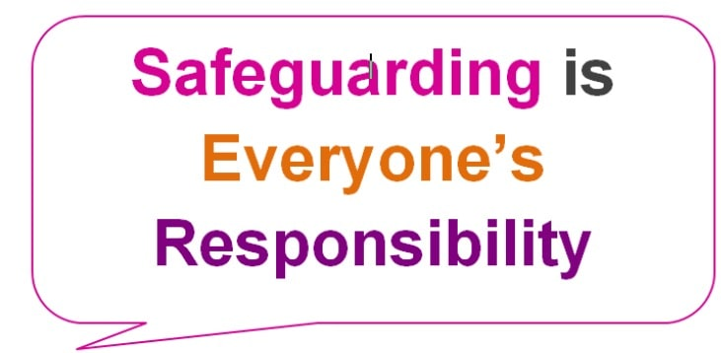
Safeguarding and well-being
A child’s welfare, well-being and safety is of the utmost importance to us. A child can’t learn or make any progress in school if they don’t feel safe or secure. We all know they need to be happy and we are here to ensure all of our children are nurtured to reach their full potential. Sometimes, learning in a lesson can trigger something to upset a child. We have a special programme in school to help any children who may be struggling with their emotions and well-being. If you have any concerns about your child or in fact another child, please do not hesitate to contact one of our Designated Safeguarding Leads, who will be happy to talk through any concerns you may have.

Personal Development

Learning a modern foreign language like German helps to promote a wider cultural awareness. As the need and ability to travel internationally becomes increasingly accessible, we recognise the importance for our children to be able to communicate in a different language effectively. Learning a language opens doors and provides more opportunities for our children to develop a greater understanding of the world and their place in it.


How can I support my child’s learning in German?
There is lots you can do to support your child with their learning of German. First and foremost, please talk to them about what they have learned in their lessons. Get them to speak some of the phrases they have learned and give them lots of praise. Germany has many interesting customs and traditions which will be good to compare with your own. Each year at Christmas, Manchester welcomes the German market stalls. Why not take a visit and savour in all of the delights?!

