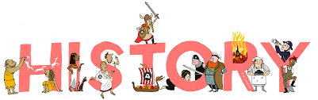
What does History look like at our school?
From Nursery, up to Year 6, your child will be taught the essential knowledge and skills taken from the Early Years Framework and the National Curriculum. Our well-planned journey through the History curriculum helps our pupils to remember their previous learning as well as learn lots of new knowledge and skills too! This well-planned journey also gives pupils the opportunity to practise some of the really important parts of the learning so that pupils can remember it in the long term and prepare them for their learning at High School whilst building a thirst for finding out more. Our curriculum is regularly refined in line with the latest guidance, subject research reports from Ofsted and current affairs.

Pupils have opportunities to build, master, and deepen their knowledge and understanding of Britain’s past and that of the wider world as well as the contribution that other cultures have towards life in modern day Britain. We recognise that our city and our respective communities are a vital resource to inspire pupils’ curiosity and to celebrate their own heritages. As soon as children come to our school, they are encouraged to explore history both on a local and global scale, by looking at the significant contributions of key individuals as well as the impact of influential groups of people and whole civilisations. Lessons are taught to encourage the children to question and think like a historian, to use a range of historical sources to support their learning and include immersive experiences that inspire our children to recognise the impact of these pioneers of the past in order to become pioneers of the future.
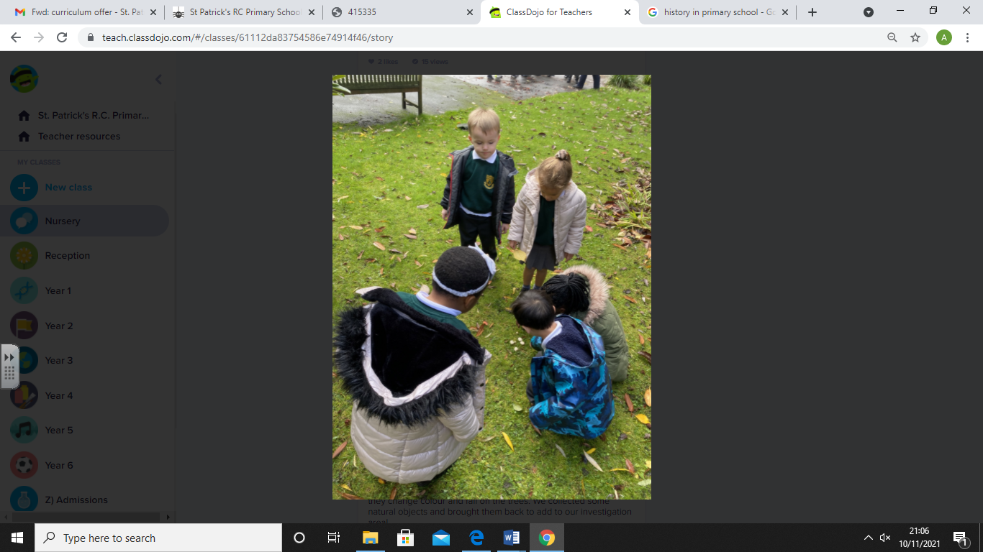
EYFS
If your child is in Nursery or Reception, they will join our Early Years Foundation Stage (EYFS). Our curriculum is taken from the statutory framework. At our school we ensure that all areas of EYFS learning are important and interconnected using planned, purposeful play and a mix of adult-led and child-initiated activities.
Your child will start to gain the historical knowledge that they’ll build on throughout their primary school years as the learning in Reception is closely linked to the learning in Year 1. Many of our history topics are built on the learning done in the ‘Understanding the World’ area, looking at ‘Past and Present’ and are closely linked to the learning in Year 1. We teach the children to talk about the lives of the people around them and learn more about their roles in society. We look at similarities and differences between things in the past and now, using their own experiences as well as through the use of engaging and purposeful texts shared in class. Through these books, the children will build an understanding of the past through settings, characters and events explored during storytelling. Children then continue their learning and further develop their understanding independently in the environment around them, we give them hands on opportunities to observe, ask and answer questions and become inquisitive. By introducing our youngest children to historical objects and photographs as well as key vocabulary, we are able to develop their inquisitive nature. This further develops their ability to find similarities and differences between the past and the present, helping to prepare them to be eager historians when they get to Year 1!
KS1 and KS2
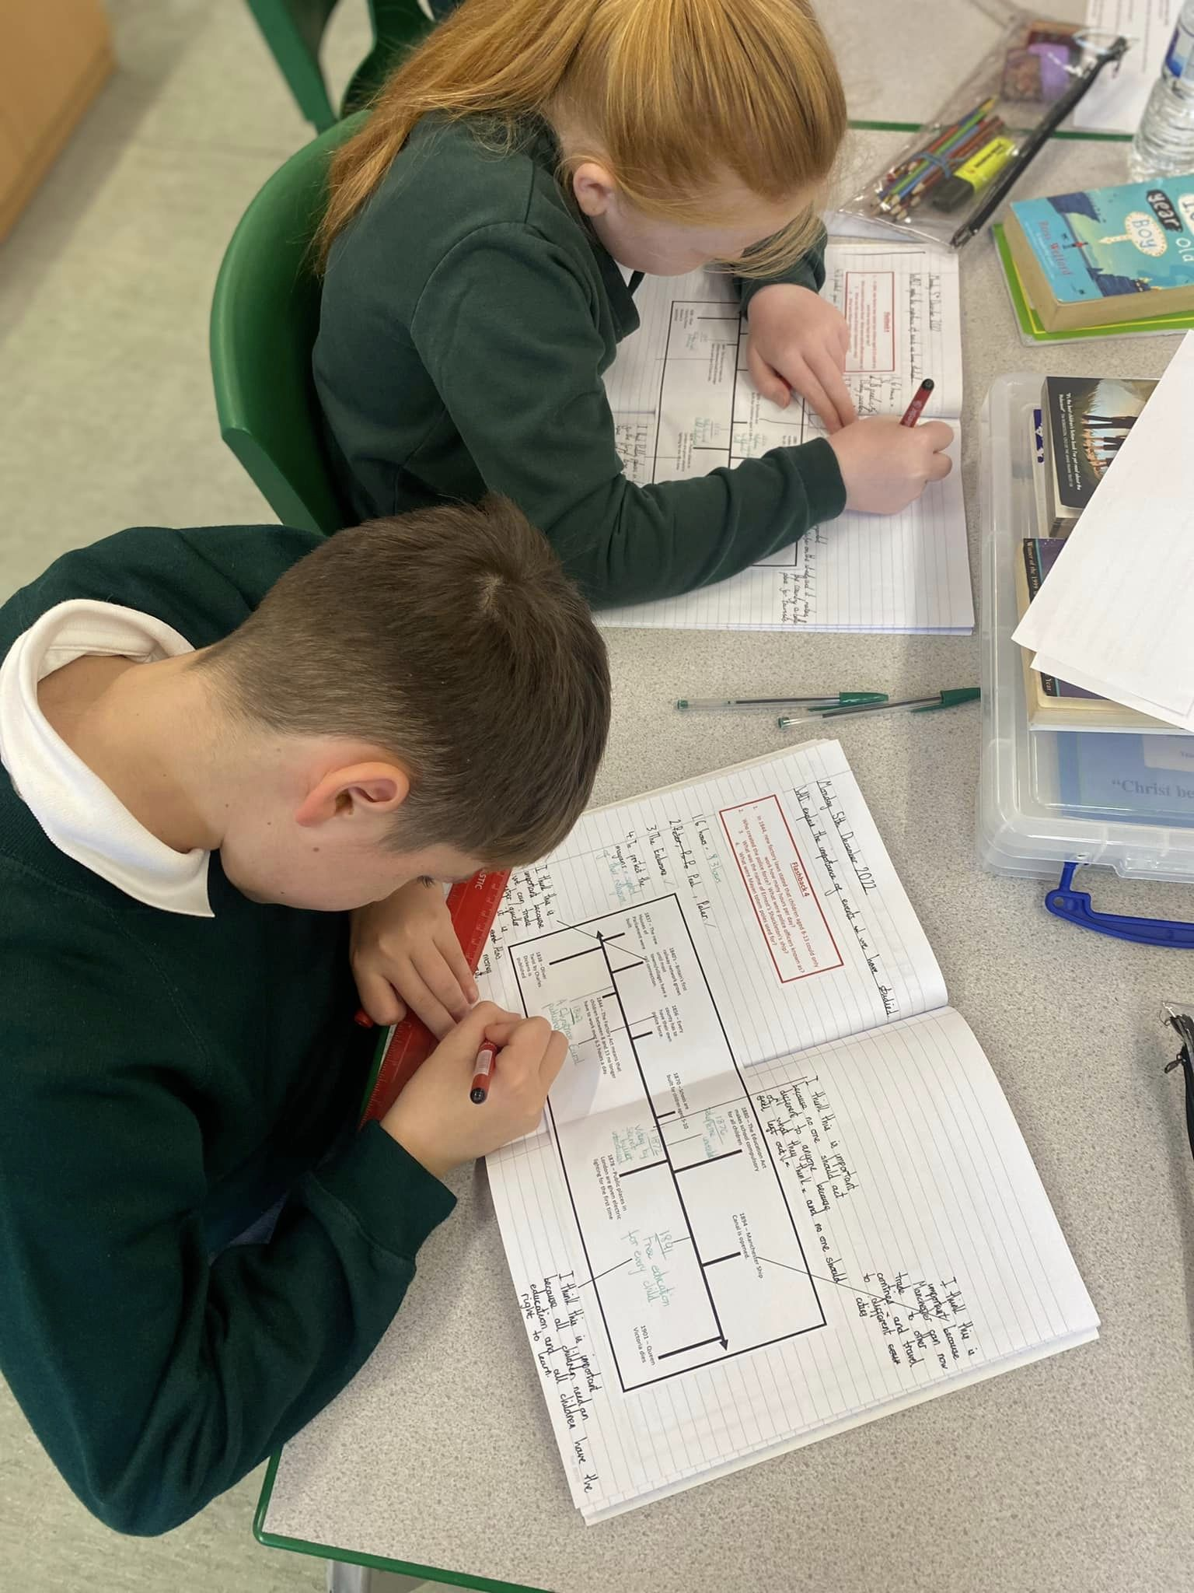
All pupils in years 1-6 receive a minimum of 1-hour History teaching a week, alternating half-termly with Geography. All History lessons start with a ‘Flashback Four’ activity that links to prior learning, enabling the children to recall information, key vocabulary and concepts taught in previous lessons. This activity helps them with their new learning, something that is particularly important as a result of the pandemic. Key vocabulary is displayed in class and explained to support the children’s learning and any new skills are modelled by the teacher before the children begin to apply these independently or as a part of a group. Each class also has their own ‘Journey through Time’ timeline which shows the periods of time the children have studied so far, including those visited in previous year groups. This is used during lessons to develop the children’s understanding of chronology and to identify where civilisations and events fit in the history of the world. The revisiting of key knowledge and skills helps the children to become more confident historians over time when using these independently.
In all History lessons, this is what you might typically see:

- Engagement and perseverance from all learners.
- Children practising skills and applying knowledge to different situations.
- Happy, confident, and independent learners.
- Children building on previous learning from other areas of history studied.
- Children working cooperatively in paired/group work.
- A classroom environment with displays including vocabulary, to support learning and reflect progression.
- Learning supported by a ‘Journey through time’ timeline in each classroom that is built on as the children move through the year groups, deepening their understanding of the past and knowing and remembering more.
- Children discussing, reflecting and sharing their learning.
- Children asking questions and discussing the contributions of significant groups and individuals and the impact they had on both British and World History.
- Lessons incorporate the use of technology where appropriate.
How do we adapt our History curriculum?
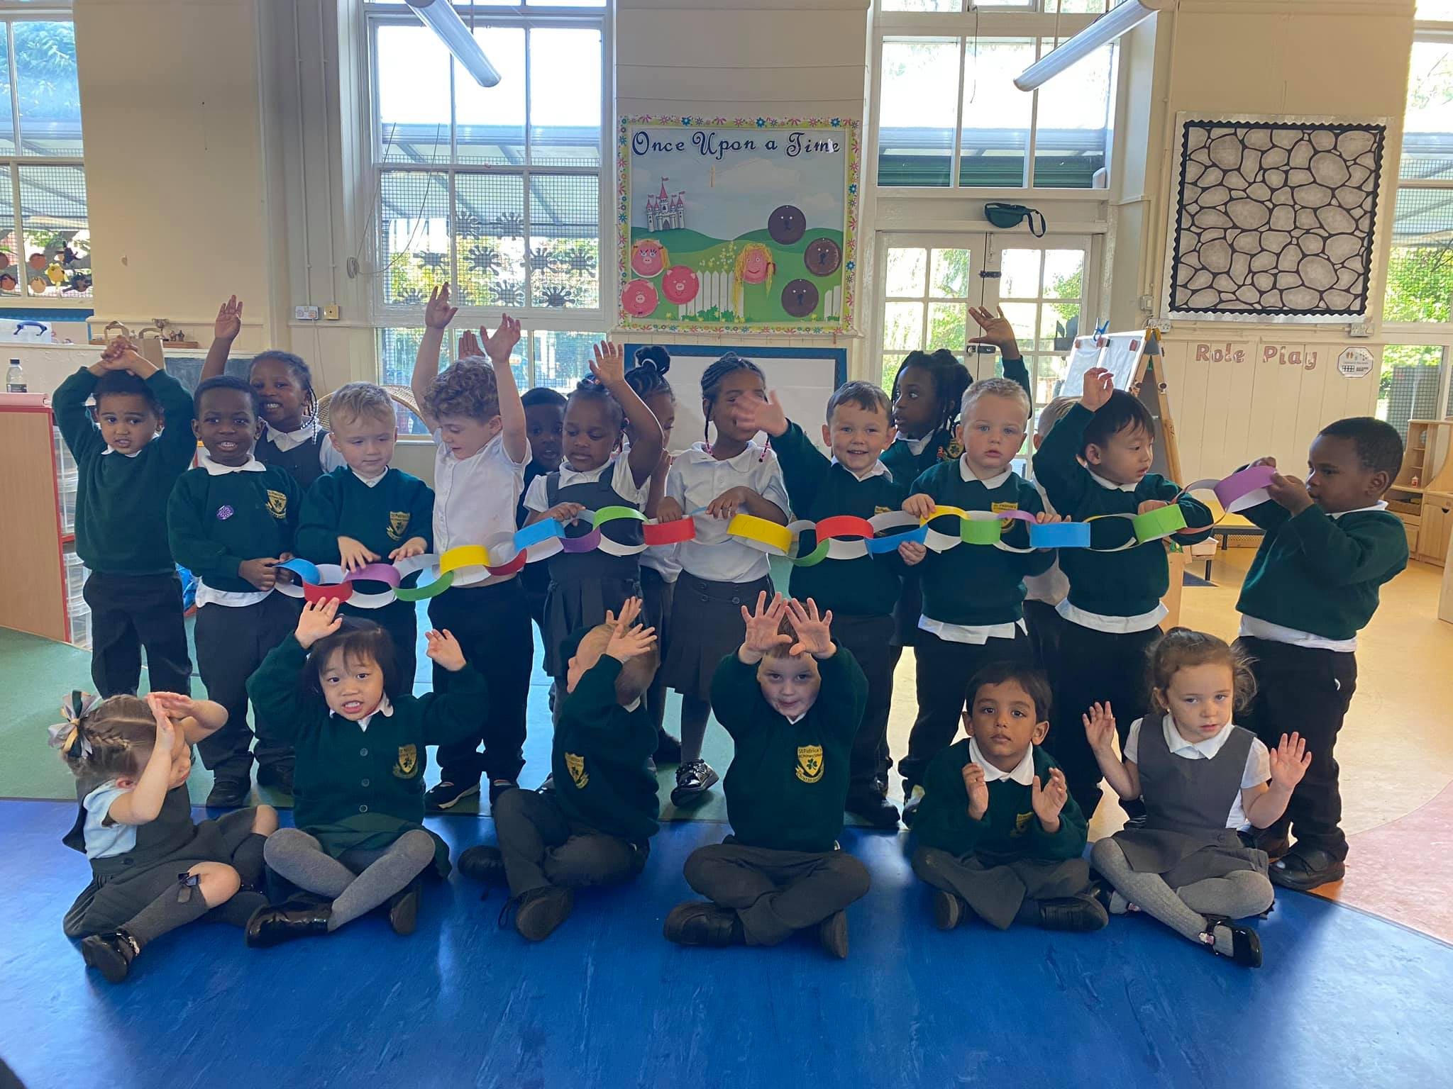
We know how important it is to give pupils the time they need to repeat or practise some of their learning so that they can remember it in the long term when they progress through school and onto High School. Our History curriculum highlights links to prior learning within history and geography and we have identified links to future topics so that teachers are aware of how the children’s current learning links to their future learning. Teachers use information from assessments to inform planning, ensuring that any foundation skills, knowledge and vocabulary that had been missed are included in planning and the delivery of teaching so that all children are given the opportunity to be successful in their learning. Teachers know that children learn at different rates and require different types of support for all sorts of reasons and our plans are adapted accordingly to meet the needs of our pupils. Our pupils love taking their learning outside of the classroom too and being able to explore what they are learning in different surroundings which is why we aim to include as many opportunities as possible to explore the local area and beyond.
How can I support my child’s learning in History?
Before we start a new History topic, your child’s ‘knowledge organiser’ will be emailed to you. This will tell you what your child will be learning in History that half term and will give you some activities you can do at home as well as showing the key vocabulary that your child will be using in class. These activities can be great fun and a good way to start conversations about their learning as well as introducing new vocabulary. These activities can be great fun and a good way to start conversations about their learning as well as introducing new vocabulary. Another great way to support learning in History is to get out and about in Manchester and the North West, you could visit some of these superb venues:
Manchester Museum – located in the University on Oxford Road, it is very family friendly and has lots of fantastic exhibitions, there are also the ‘Big Saturday’ events with a new topic being covered each month and it’s free!
Imperial War Museum
People’s History Museum
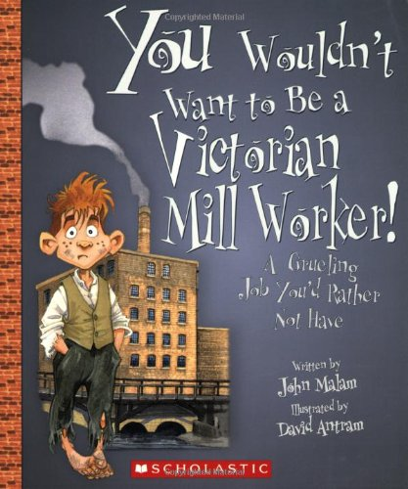
BBC Bitesize also has tonnes of information on their website which will also help with our History curriculum and they have little quizzes which children love to do.
Reading
What has History got to do with reading? Well, if your child is struggling to read, they aren’t going to be able to access the curriculum. Lots of the sources used and information children have to use in history are written down and the children need to be able to read them, as well as using the fantastic texts we have in our school to support the teaching of history! We have a saying in our school, ‘we learn to read so we can read to learn.’ So, please support your child with all of their learning by hearing them read each night. We have plenty of books to support our history curriculum. Children can learn about inspirational figures and civilisations who have changed our world for the better by reading books in our classroom libraries and school library.
Assessment
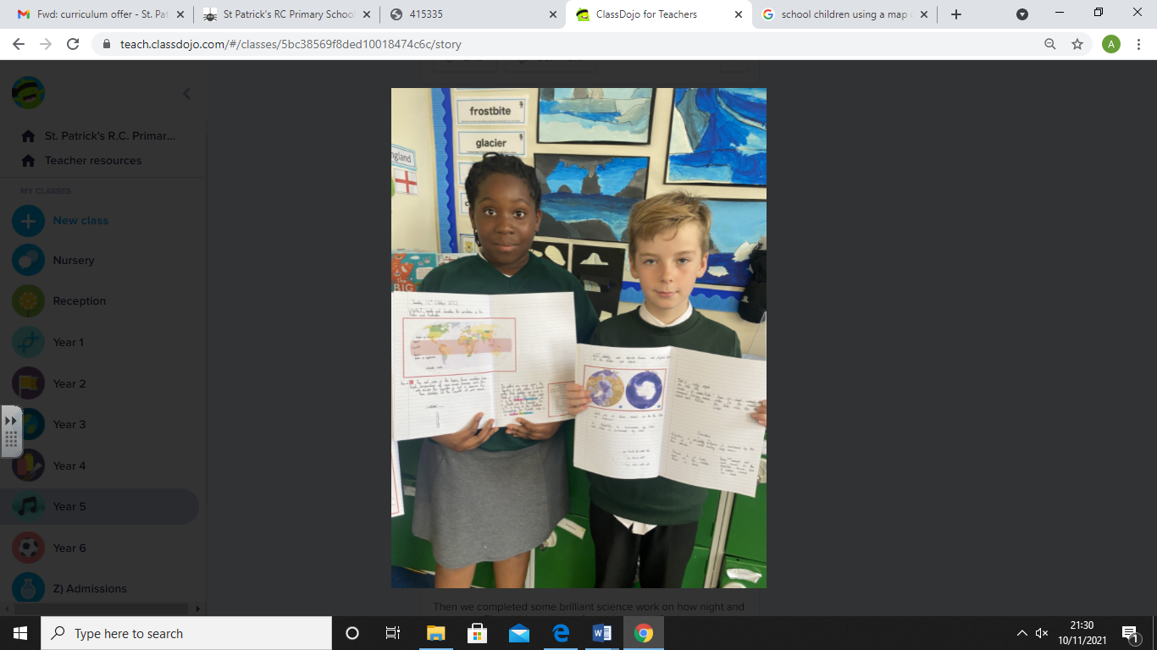
We know that it is important to monitor children’s progress in school across the curriculum, one way to do this is through assessment and teachers are continually assessing the children in all types of ways so they can help them progress further with their learning. Assessment in History is carried out within each lesson and at also at various points throughout the school year. Children are provided with next step marking and feedback from their teachers and peers that help to extend children’s learning as well as finding out what they do or do not know so that they can give the right support.
All KS1 and KS2 classes complete an assessment at the end of each topic and these can take a variety of forms e.g. quizzes, information leaflets and fact files that assess what has been taught that half term. This will then inform teacher assessment for History at different points in the year and helps us to understand where there are gaps in learning. These assessments also help the teachers understand what knowledge the children have remembered from previous year groups.
Who do I speak to if I want to know more about what my child is learning in history at school?
Your child’s class teacher knows your child best and is best placed to keep you informed about the content of history lessons. Miss Loughrey is our History Subject Leader and she will also be only too happy to answer any questions, queries or concerns that you may have about all things history!
Extra Support
During their time at school, some children may need extra support in various areas of the history curriculum, this is because children learn at different paces and have different learning styles. It isn’t anything to worry about and it is good that we can provide them with extra help when needed. Here are some of the ways we provide extra support during our History lessons at school:
- We have as many practical history lessons as possible because we know this really helps children to remember what they are learning
- We use teacher and self-assessment to quickly identify any child who requires additional support in specific areas.
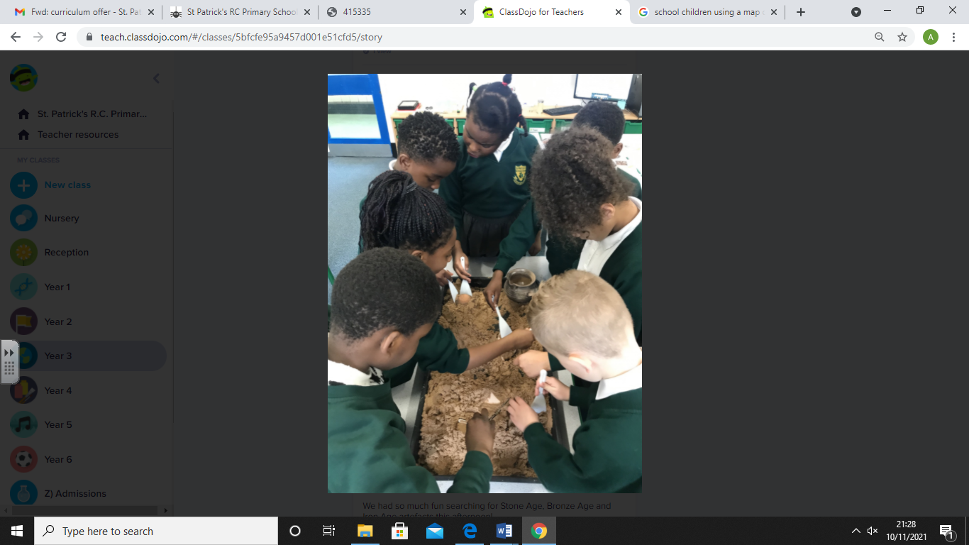
- Differentiated ability tasks enable children to progress at their own pace.
- We celebrate individual pupil progress in their learning journey.
- We make cross curricular links whenever possible.
- Provide visual and practical prompts as well as using step by step approaches, ‘guided talking’, thinking aloud in front of pupils, questioning etc particularly to support new skills being taught.
- We encourage all children to be positive learners and teach children strategies to help them persevere when overcoming challenges in their learning.
- Teaching lessons using a range of different techniques to appeal to different learning styles e.g. videos, interactive websites, drama, equipment, texts etc.

If you think that your child would benefit from some extra support in History, please speak to your child’s class teacher or make an appointment to speak to our SENDCo, Mrs Shaw.

Safeguarding and well-being

A child’s welfare, well-being and safety is of the utmost importance to us. A child can’t learn or make any progress in school if they don’t feel safe and secure. We all know they need to be happy and we are here to ensure all of our children are nurtured to reach their full potential. Sometimes, learning in a lesson can trigger something to upset a child. We have a special programme in school to help any children who may be struggling with their emotions and well-being. If you have any concerns about your child or in fact another child, please do not hesitate to contact one of our Designated Safeguarding Leads who will be happy to talk through any concerns you may have.

Personal Development
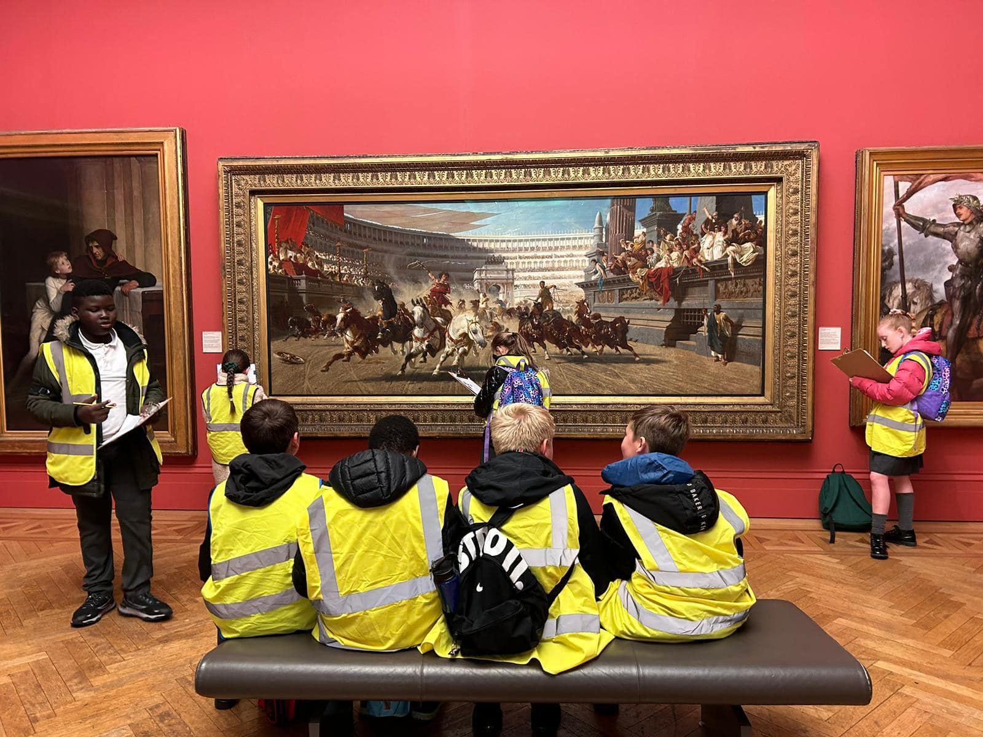
In addition to our exciting and stimulating curriculum, we also provide further opportunities to enhance children’s learning wherever possible. We offer a range of different enrichment activities and events in order to ensure we are equipping our children with the knowledge and cultural capital to succeed in life.
Through our history curriculum we are working to ensure that children are able to recognise the links between their history lessons and how these events have had an impact on their own lives today.
We aim to help our pupils gain knowledge and understanding of Britain’s past and that of the wider world. We aim to inspire pupils’ curiosity to know more about the past, to understand how the actions of an individual or group of people changed the course of history, the diversity of societies and relationships between different groups, as well as their own identity and the challenges of their time. We will teach the pupils a sense of chronology, and through this they will develop a sense of identity and will learn to value their own and other people’s cultures in modern multicultural Britain. By considering how people lived in the past, they are better able to make their own life choices today.

