What does English look like at our school?
Our English curriculum has been designed around the requirements of the National Curriculum as this sets out what our pupils need to learn. The programmes of study are the basis for learning so we have used this to establish a plan to teach this content. We have made some adaptations to make sure the content is both current & relevant to the 21st century, reflects the needs of our pupils so that they can be better prepared for the diverse area in which they live. We also refine our English curriculum in line with the latest guidance, subject research reports from Ofsted and current affairs.
Reading
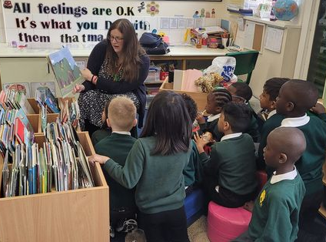
Teaching reading is our priority and we aim for all children to be competent readers by the time they leave our school. This means your child should at least have a reading age to match their chronological age but ideally, we would want it to be higher than that. We believe that children learn to read so that they can read to learn and so fostering a love of reading is at the heart of our English curriculum. Our school makes story and poetry time the highlight of every day; to read and re-read stories to our children and make books available for them to enjoy at home. A primary focus is to ensure that our children see themselves, their families and their cultures reflected and celebrated in the books and stories we have on offer in school. In response to this, we have purchased a wide selection of inclusive and diverse books for every year group to enjoy both in school and at home which we hope will give your child plenty to talk about and share their ideas with you.
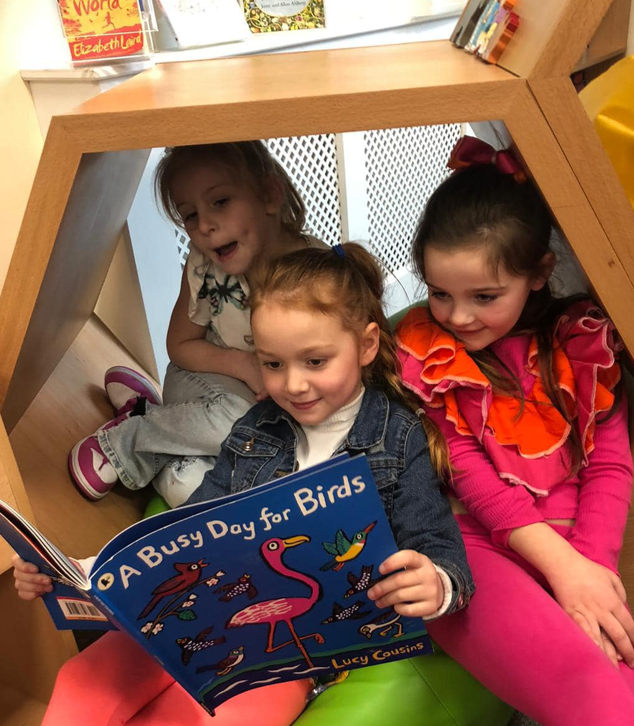
Early Reading (Phonics)
The teaching of phonics takes place every day for all children from when they are settled in Nursery. The children are taught in small groups so that we can really focus on the sounds they are ready to learn. At this early stage, children are given reading books that will help them decode and practice the words they are learning in lessons. Therefore, it is really important that they read and practice each evening with an adult. It will only take 10 minutes of your time.

At our school, when children first come to us, we know that most of the children do not know as many sounds as they should for their age. Don’t worry, teachers work hard to address this and this is the reason why we get started as soon as we can! Teachers will also revisit lots of sounds to make sure every child knows every sound they need to know. We might find that your child needs a little bit of extra support with either their early language development or sounds so we are providing additional daily phonics practice for some children as well as a really good language programme to help the very young children. You might want to know more about how we teach early reading so that you can help your child at home. We use a programme called, ‘Read/Write Inc’ which is very successful and popular in a lot of schools. You can watch lots of videos about how to help your child with phonics on YouTube. Just do a search for ‘Read/Write Inc.’ Your child’s teacher will be more than happy to help explain why we teach early reading the way we do.
What happens once my child knows their sounds?
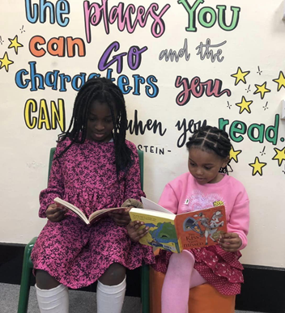
Once your child knows their sounds, they will work their way through the reading book bands. These are assigned to your child based on their de-coding and comprehension skills. Often, we find with young readers, they can de-code words and even read fluently but they don’t always understand the context of what they are reading. Parents can play a significant role in helping teach your child to read and we ask you to either hear your child read or share a book with them each night. It’s crucial that they learn to read for pleasure and we are delighted that every child in the school will have the opportunity to visit the library on a weekly basis; to choose and enjoy a range of books with their friends. Your child should be bringing home a book which will help them learn to read along with another book (often a picture book) which they should enjoy reading and sharing with you.
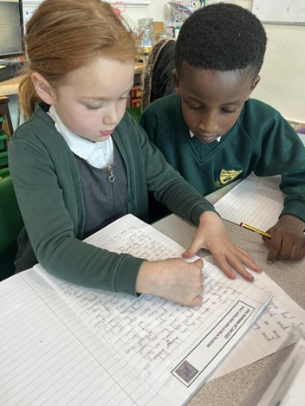
English lessons Children in Years 1 & 2 have a daily English lesson. Across the week, this will include a range of teaching activities that incorporate the skills learnt through phonics, reading, speaking and listening and sentence level work (including punctuation and grammar). Children in Years 3-6 also have a daily English lesson. This will include a range of teaching that incorporates the skills learnt through their weekly spelling practice and guided whole class reading. Therefore, it is vitally important that your child really puts 100% effort into learning their weekly spellings at home. The teachers will have taught your child the ‘look, say, cover, write, check’ method to help them. Again, this is something you can support your child with at home. The teaching of punctuation and grammar is mostly embedded within English lessons, so that the children are better equipped to apply these skills to their own writing. However, when an extra focus on an area of learning is required, a stand-alone session will be taught. In all classes, there is a strong focus on literature with teachers using high-quality texts to engage and challenge learners. From early years to Year 6, teachers plan a wide range of opportunities for children to practise their reading and writing skills within other curriculum areas. You will see English skills being taught in all lessons, not just an English lesson. Time is also given for children to practise their handwriting regularly to increase its fluency, legibility and quality. We have some very special handwriting books which children can use to practise at home. If you would like one of these books, please get in touch with your teacher and we can send one home.
Teachers are mindful that children learn at different rates and require different types of support for all sorts of reasons. Therefore, they adapt their lesson planning accordingly. For example, shorter writing tasks rather than extended pieces allow children to focus on important sentence structure and their spelling. However, this doesn’t mean we lower our expectations, we will continue to challenge our children to do their very best!
Any questions you have about our English curriculum can be addressed by either your child’s class teacher or our English Leaders, Mrs Fox and Mrs Betney.

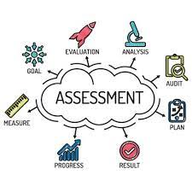
Assessment
Assessment has to serve a purpose and teachers are continually assessing the children in all types of ways so they can help them progress with their learning. In every English lesson teachers are questioning and discussing with pupils to find out what they do or do not know so that we can give extra support. We have weekly spelling tests that are taken from the set sounds being learnt that week in Phonics for Early Years and Year 1. For Years 2-6, spellings are taken from the National Curriculum spelling lists as well as spelling rules learnt that week.
Each term, children will be given a reading and writing assessment. These help the teachers see where there are gaps in learning and help them to plan for what needs to be taught the following term. The tests also show the children what fantastic progress they have made and what they need to learn next. Assessment results are shared with parents mid-way through the year so you can see how well your child is doing.
Extra support
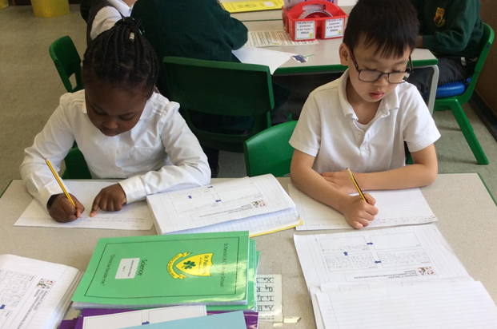
During their time at school, some children may need extra support in various areas of the English Curriculum, this is because children learn at different paces and have different learning styles. It isn’t anything to worry about and it is good that we can provide them with extra help when needed. At our school, we use our teaching assistants in class to provide extra support to the children who need it. They also do some extra intervention work as well and this is really targeted at certain concepts that are essential for a child to make progress in English. This can be 1:1 with a child or small group work. If you think that your child would benefit from some extra support, please speak to your child’s class teacher or make an appointment to speak to our SENDCo, Mrs Shaw.
Safeguarding and well-being
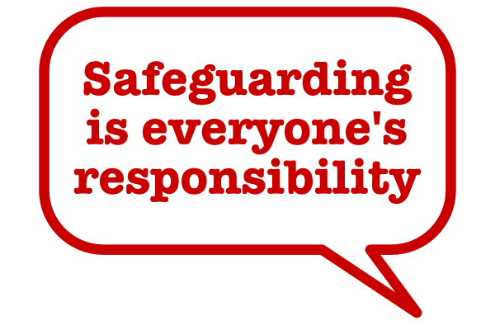
A child’s welfare, well-being and safety is of the utmost importance to us. A child can’t learn or make any progress in school if they don’t feel safe and secure. We all know they need to be happy and we are here to ensure all of our children are nurtured to reach their full potential. Sometimes reading something in a book or learning in a lesson can trigger something to upset a child. We have a special programme in school to help any children who may be struggling with their emotions and well-being. If you have any concerns about your child or in fact another child, please do not hesitate to contact one of our Designated Safeguarding Leads who will be happy to talk through any concerns you may have.
Personal Development
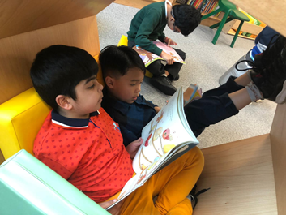
We are delighted that our book den is back open so children have the opportunity to choose and share books with their friends either during the school day and at lunchtime. We have lots of new books for the children to enjoy – many will get the children thinking about worldly issues and we hope spark off debates! We know that reading, escaping into a book, has a really positive impact on our well-being so it is a habit worth forming! We look forward to having visiting authors into school again, celebrating World Book Day and making the most of what Manchester has to offer!


An important message to our children
At our school

- You will learn to read
- It doesn’t matter how long it takes for you to learn. We will go at your pace.
- We want you to love reading books
- We want you to love reading different types of books
- We will introduce you to lots of different books to read
- We want you to love our book den
- We want you to tell us what you’d like to read
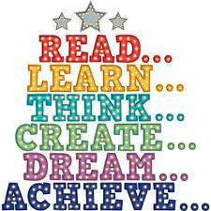
- We want you to tell us who you’d like to read (the authors)
- We want to make sure you are represented in the books we give you to read
- Your opinion matters so please speak up
- We want you to talk to your friends & teachers about the books you read
- We want you to learn new vocabulary (words) from the books you read

If you ever have any worries or problems, you know you can talk to any member of staff. We are all here to listen to you.



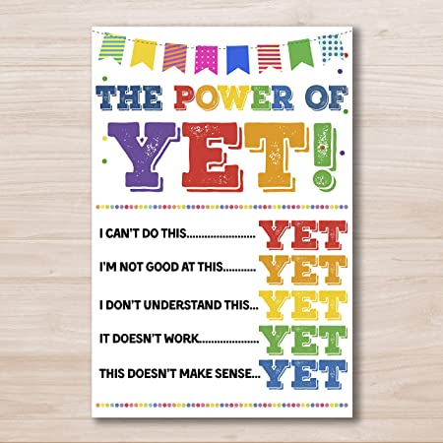
We are proud to be Catholic Mancunians

