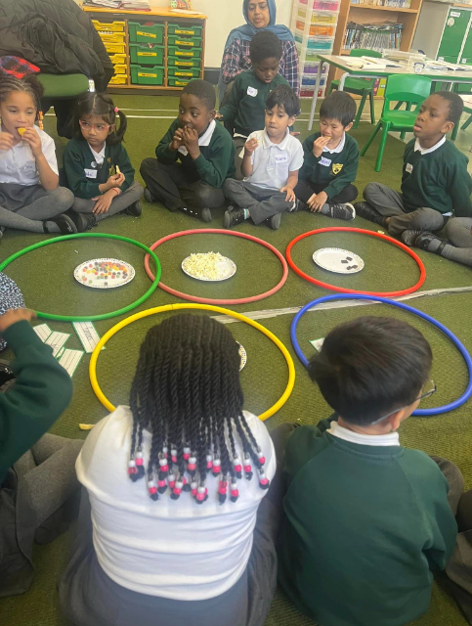
What does Science look like at our school?
The curriculum is designed to meet the aims of the National Curriculum whilst building scientific minds, a wealth of knowledge and a thirst for finding out more. The National Curriculum sets out what pupils need to learn which we cover through The White Rose scheme that we have adopted. The schemes have been designed to allow good coverage of the age-related expectations for the curriculum as well as providing continuity and progression throughout each year group. We also regularly refine the curriculum in line with the latest guidance, subject research reports from Ofsted and current affairs.

As soon as children come to our school, they are encouraged to explore the world around them by looking at similarities, differences, patterns and change. Lessons are taught to encourage the children to think scientifically, use a range of equipment and conduct practical experiments whilst inspiring our children to present what they have found out in a range of different styles.

EYFS
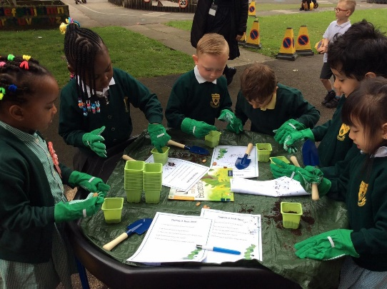
If your child is in Nursery or Reception, they will join our Early Years Foundation Stage (EYFS). Our curriculum is taken from the statutory framework. At our school, we ensure that all areas of EYFS learning are important and interconnected using planned, purposeful play and a mix of adult-led and child-initiated activities.
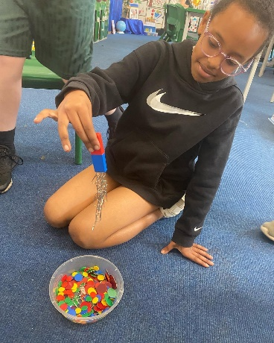
Your child will start to gain the scientific knowledge that they’ll build on throughout their primary school years. Many of our science topics are covered in the ‘Understanding the World’ and are closely linked to the learning in Year 1. We teach the children to explore the environment around them and give them hands on opportunities to investigate, observe, ask and answer questions and become inquisitive. For example, ‘What would happen if I didn’t give a plant water?’ observing objects closely, using simple equipment such as a magnifying glass, using their observations to suggest answers to questions and gathering and recording data to help in answering questions. This will help them get ready to be eager scientists when they get to Year 1!
KS1 and KS2
In all Science lessons, this is what you might typically see:
- Engagement and perseverance from all learners.
- Children practising and applying knowledge to different situations.
- Happy, confident, and independent learners.
- Children posing their own questions and hypothesis for investigation
- Children working cooperatively in paired/group work.
- A classroom environment with displays including vocabulary, to support learning.
- Children discussing, reflecting and sharing their learning.
- There are regular practical sessions where children have opportunities to develop their investigative skills. A range of engaging resources enable the children to carry out exciting experiments to deepen their learning and develop their understanding of the concept that is being taught.
- Lessons incorporate the use of technology where appropriate.
- Displays support current learning which include vocabulary and reflect progression in learning.
How can I support my child’s learning in Science?
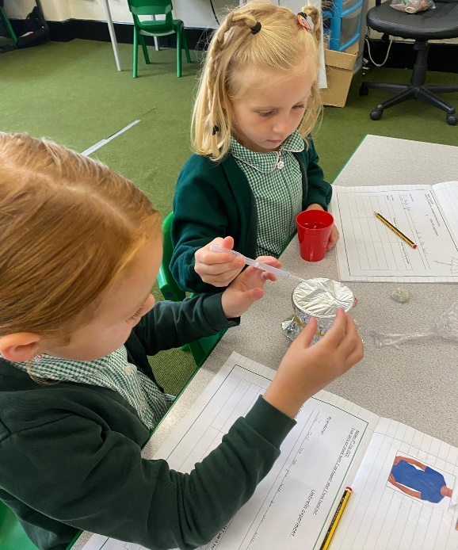
It would be fantastic if you could support your child’s learning at home! Before we start a new topic, your child’s ‘knowledge organiser’ will be available for you via Email. This will tell you what your child will be learning in Science and will give you some activities you can do at home. These activities can be great fun and a good way to start conversations about their learning as well as introducing new vocabulary. Another great way to support learning in Science is to get out and about in Manchester and the North West and visit some of these superb venues:
Manchester Science and Industry Museum – in the city, lots of fantastic exhibitions and it’s free!
Jodrell Bank Discovery Centre
Eureka!
BBC bitesize has tonnes of information on their website which will also help with our Science curriculum and they have little quizzes which children love to do.
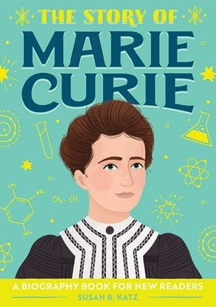
Reading
What has reading got to do with science? Well, if your child is struggling to read, they aren’t going to be able to access the curriculum. Lots of the instructions and experiments children have to investigate in science are written down and the children need to be able to read them. We have a saying in our school, ‘we learn to read so we can read to learn.’ So, please support your child with all of their learning by hearing them read each night. We have plenty of books to support our science curriculum. Children can learn about inspirational figures who have changed our world for the better by reading books in our library.

Assessment

Assessment has to serve a purpose and teachers are continually assessing the children in all types of ways so they can help them progress with their learning. Assessment in Science is carried out within each lesson and at also at various points throughout the school year. Children are provided with next step marking and feedback from their teachers and peers; there are displays of work around school.
KS1- All KS1 classes complete an assessment at the end of each topic- this will then inform teacher assessment for Science at different points in the year and helps us to understand where there are gaps in learning.
KS2 – All KS2 classes complete an assessment before the topic, to help the teachers understand what knowledge the children have remembered from previous year groups and an assessment at the end of each topic to assess what new learning the children have remembered.
Extra Support
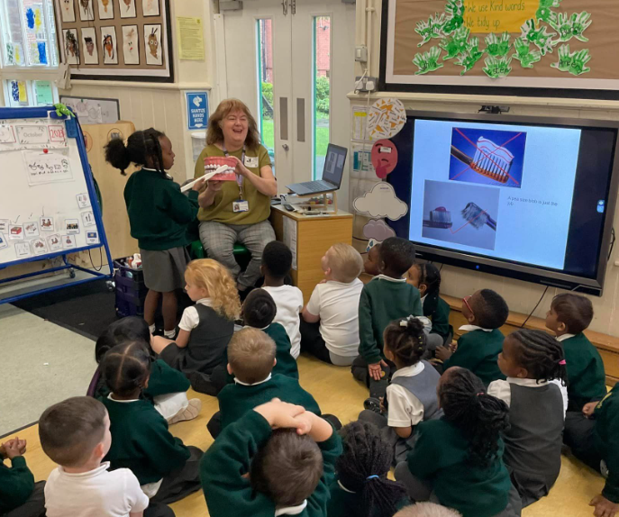
During their time at school, some children may need extra support in various areas of the science curriculum, this is because children learn at different paces and have different learning styles. It isn’t anything to worry about and it is good that we can provide them with extra help when needed. Here are some of the ways we provide extra support during our Science lessons at school:
- We have as many practical science lessons as possible because we know this really helps children to remember what they are learning
- We use teacher and self-assessment to quickly identify any child who requires additional support in specific areas.
- We celebrate individual pupil progress in their learning journey.
- Differentiated ability tasks enable children to progress at their own pace.
- We make cross curricular links whenever possible.
- Provide visual and practical prompts. Step by step approaches, ‘guided talking’, thinking aloud in front of pupils, questioning etc.
- Teaching lessons using a range of different techniques to appeal to different learning styles e.g. videos, interactive websites, drama, equipment, texts etc.

Safeguarding and well-being

A child’s welfare, well-being and safety is of the utmost importance to us. A child can’t learn or make any progress in school if they don’t feel safe and secure. We all know they need to be happy and we are here to ensure all of our children are nurtured to reach their full potential. Sometimes, learning in a lesson can trigger something to upset a child. We have a special programme in school to help any children who may be struggling with their emotions and well-being. If you have any concerns about your child or in fact another child, please do not hesitate to contact our Designated Safeguarding Lead, Mr Usher and he will be happy to talk through any concerns you may have.

Personal Development
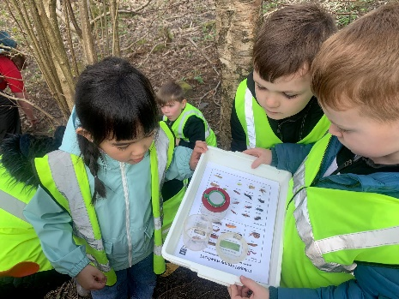
In addition to our exciting and stimulating curriculum, we also provide further opportunities to enhance children’s learning wherever possible. We offer a range of different enrichment activities and events in order to ensure we are equipping our children with the knowledge and cultural capital to succeed in life.
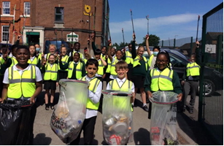
Through our science curriculum, we are ensuring that children are able to recognise the link between their science lessons and the significance to their own lives. We aim to help children appreciate the history of science and how it has changed and continues to change the world they live in.
We want our students to feel that their science lessons reflect our society and our greater society; learning based on their race, sex, social background etc. We want to break down any stereotypes and increase positive attitudes in science lessons so there is an impact on their attainment and progress.
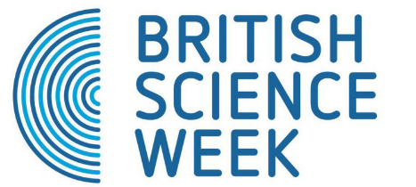
Alongside our weekly science lessons and educational trips and visits, we also have many whole school events and themed events:
- British Science Week: ‘Innovating the Future’ – focussing on NHS careers and inviting professionals into our school.

- Great Science Share: ‘Climate Emergency’ – the whole school focussed on 'activism' and gave our children the knowledge and inspiration of how they can change the world. Looking at the current activists... Greta Thunberg, David Attenborough, Jane Goodall etc but then through investigations express the desire that our children could then be the activists of the future; introduction of public speaking, debate into our classrooms.

- Year Group Scientist Study - BAME community, Mancunians, Inspirational Women in Science – built upon previous units in other year groups/topics. (Turing, Tim Berners-Lee, Mangala Mani – Antarctic Scientist, Mae C. Jemison).
Supporting and providing opportunities for children to participate in STEM initatives such as World Science Week 2022 – focussing on Women in Space.
- Christmas Science Day - focusing on Christmas themed STEM based activities

